・次の写真を【仮主語＋不定詞】を用いた英文で表しなさい。

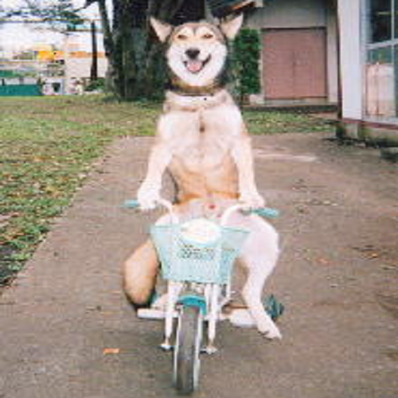
(例) It is easy for the dog to ride a bike. ]

①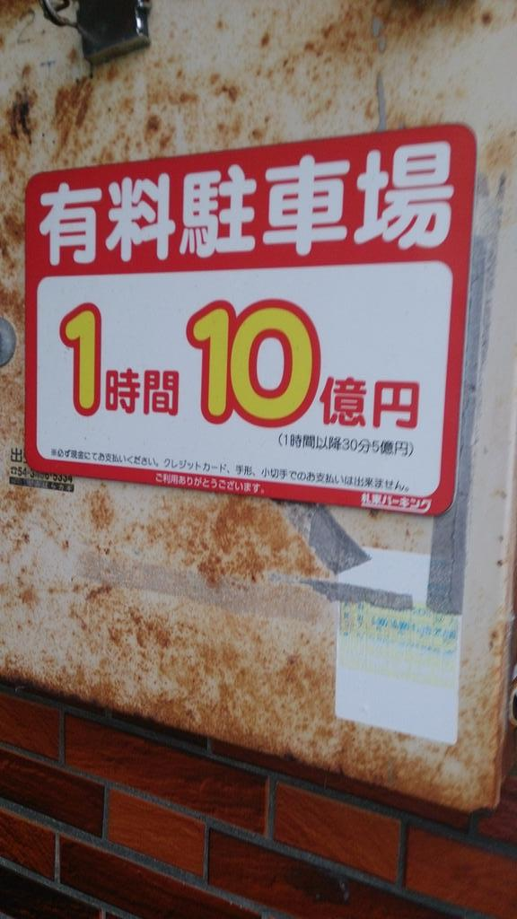 ②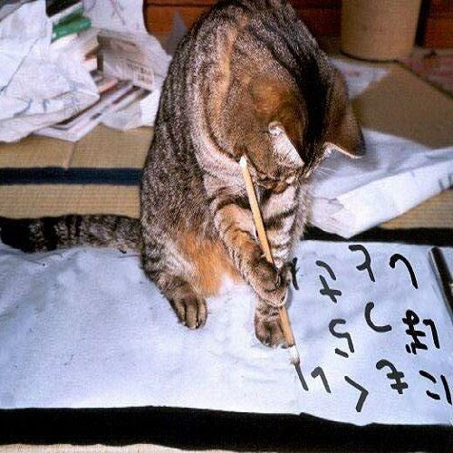

③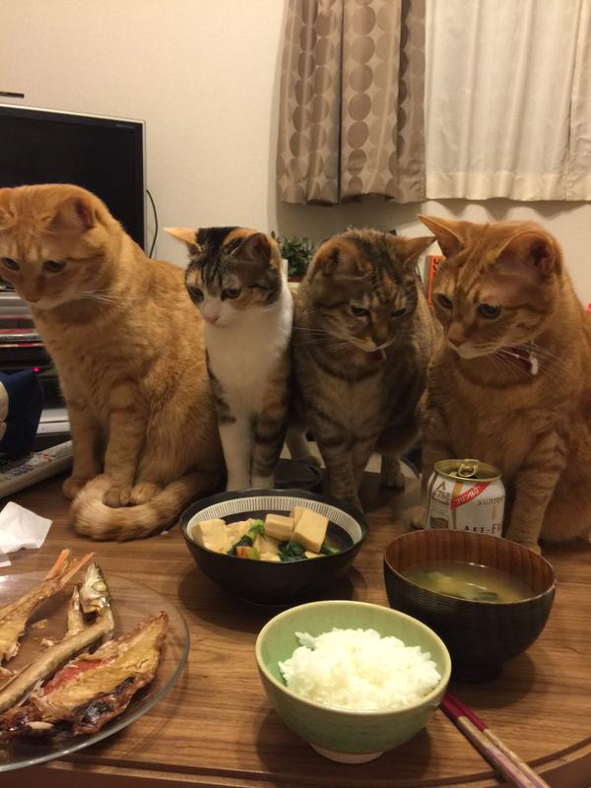 ④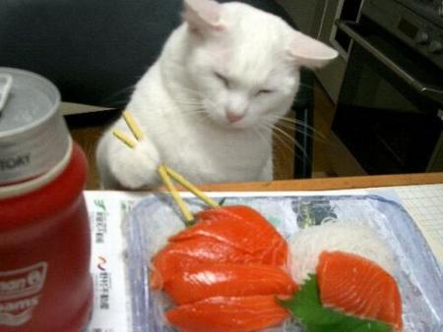

⑤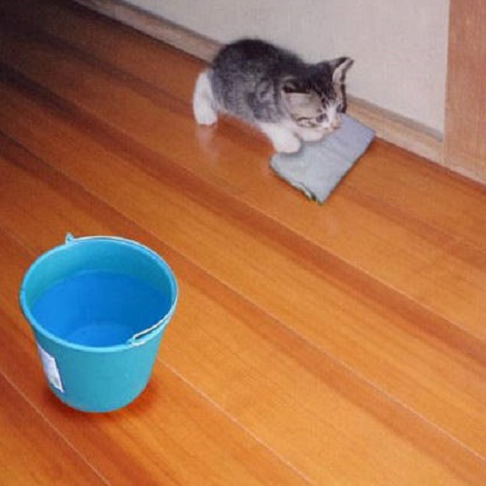 ⑥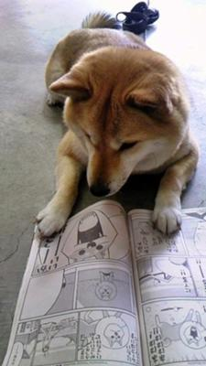

⑦ ⑧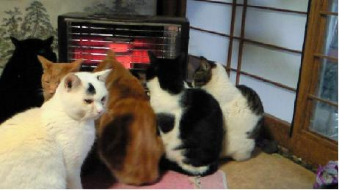

⑨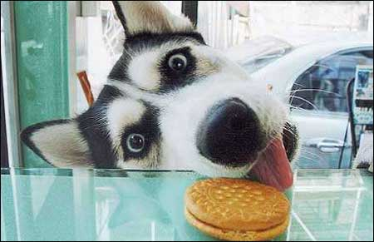 ⑩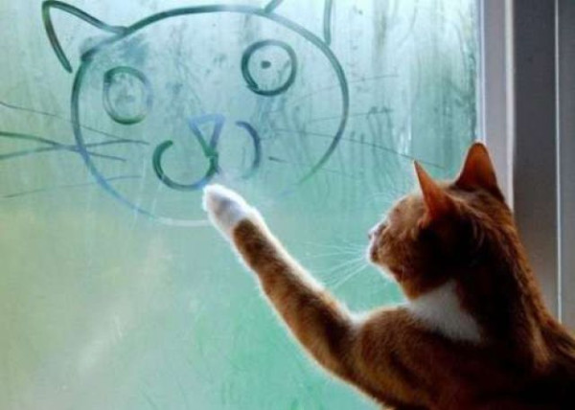

⑪ ⑫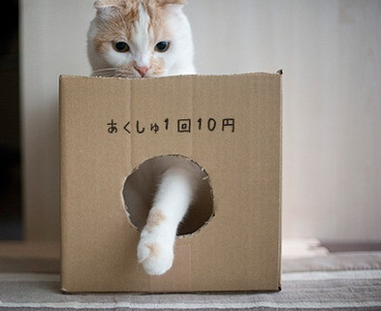

⑬ ⑭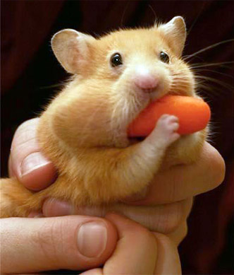

⑮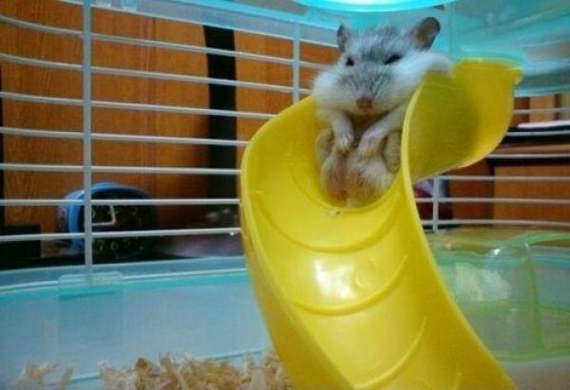 ⑯

⑰ ⑱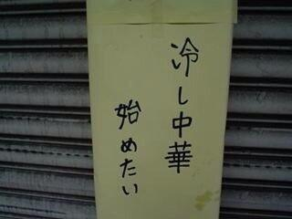

⑲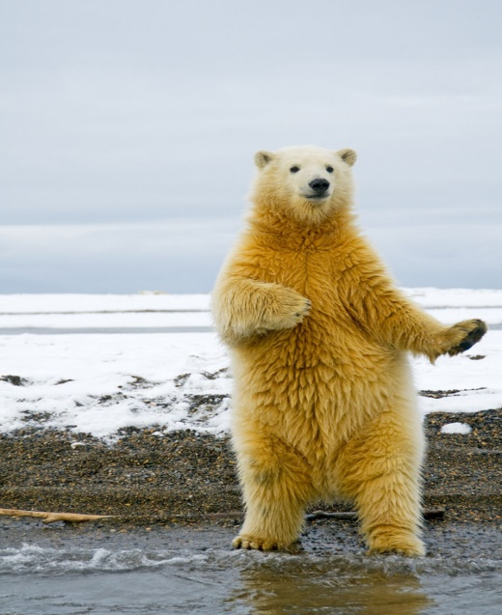 ⑳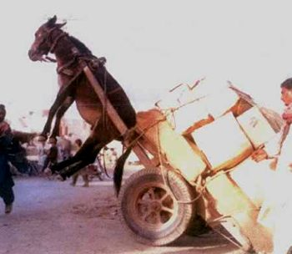

㉑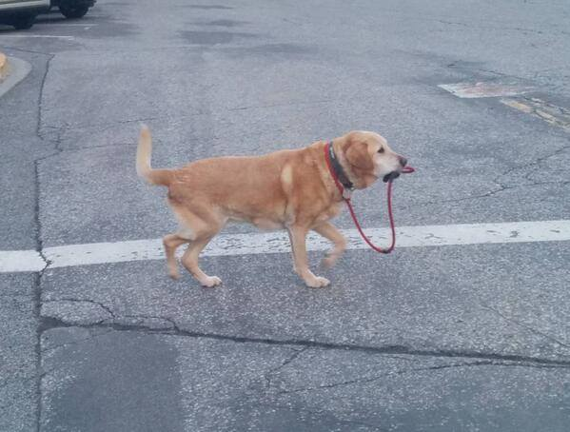 ㉒

㉓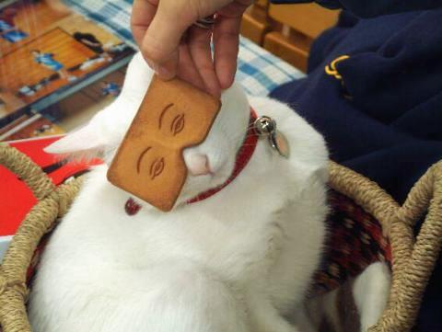 ㉔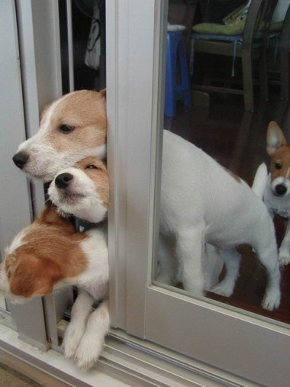

㉕ ㉖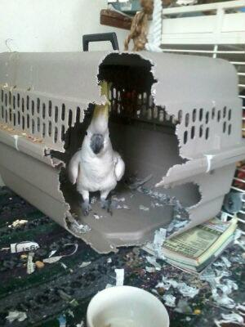

㉗ ㉘

㉙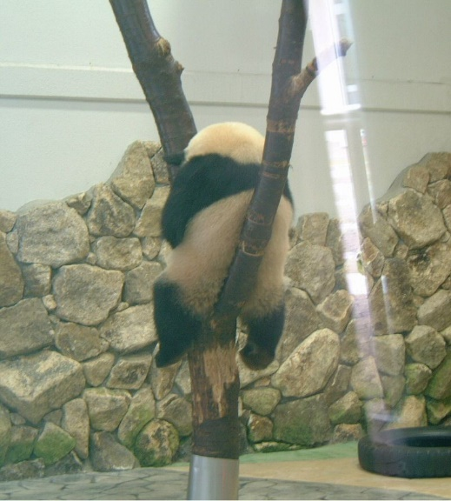 ㉚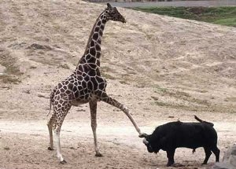

㉛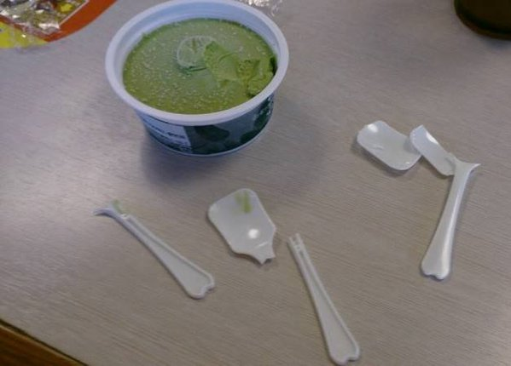 ㉜

㉝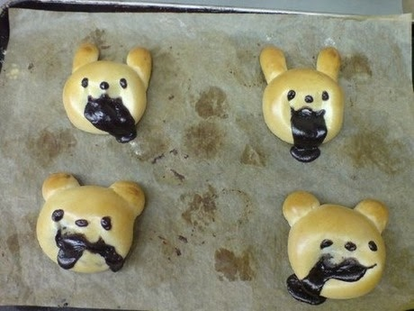 ㉞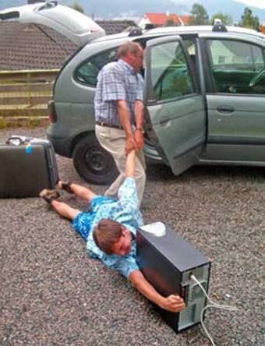

① It is very difficult to park a car here. (park「駐車する」)
② It is easy for the cat to write a letter.
③ It is difficult for the cats to choose which food to eat. (どの食べ物を選ぶか)
④ It is easy for the cat to use chopsticks.
⑤ It is easy for the cat to clean the floor.
⑥ It is pleasant for the dog to read comic books.
⑦ It is difficult to hug the cat.
⑧ It is impossible for the white cat to sit in front of the heater.
⑨ It is difficult for the dog to get the biscuit.
⑩ It is easy for the cat to draw a picture.
⑪ It is difficult for the monkey to drink the water.
⑫ It is easy for the cat to earn money.
⑬ It is easy for the cat to tear the paper. (tear 破る)
⑭ It is difficult for the hamster to eat a carrot.
⑮ It is impossible for the hamster to enjoy the slide. (slide 滑り台)
⑯ It is pleasant for the cat to play with toilet paper.
⑰ It is impossible for the cat to calculate. (calculate 計算する)
⑱ It is difficult for the restaurant owner to start selling Hiyashichuka noodle.
⑲ It is pleasant for the bear to dance hula.
⑳ It is impossible for the donkey to pull the cart.
㉑ It is pleasant for the dog to go for a walk alone.
㉒ It is impossible for the cat to take off the hanger.
㉓ It is unpleasant for the cat to wear a mask.
㉔ It is difficult for the dogs to go out of the room at the same time.
㉕ It is difficult for the dog to catch a Frisbee.
㉖ It is easy for the bird to get out of the pet carrier.
㉗ It is difficult for the white cat to breathe. (breathe 呼吸する)
㉘ It is difficult to kiss the cat.
㉙ It is difficult for the panda to climb down from the tree.
㉚ It is difficult for the bison to defeat the giraffe.
㉛ It is difficult to eat this ice cream.
㉜ It is impossible for the cat to use its front paws. (front paw 動物の前あし)
㉝ It is difficult to bake cute bread.
㉞ It is difficult for the father to go out with his son.

